This homework assignment is based on chapter 4 loops

**There are 3 projects, each worth 33.3%**

Complete the following programs using either the while or for loop.

**Project #1**

**#1 print screen the code with output below here.**

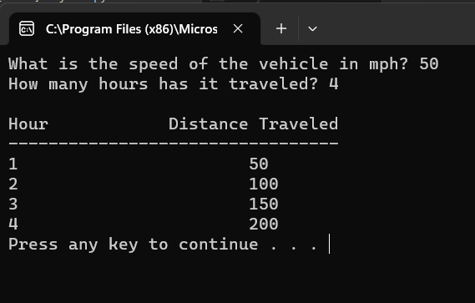

**Project #2**

**#2 print screen the code with output below here.**

**Project #3**

**#3 print screen the code with output below here.**

**Submit this document to module 3 homework.**